Working on data lake container using cloudshell bash instance.

1. Copy the reuqired file from the data lake container to the local machine.

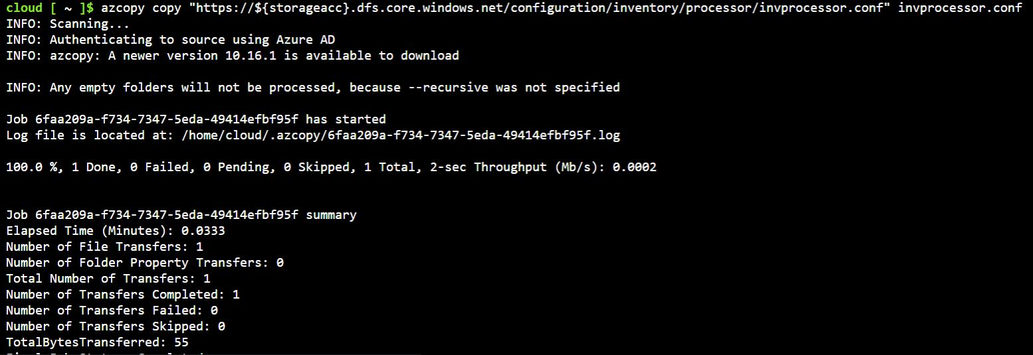

1. Make changes to it

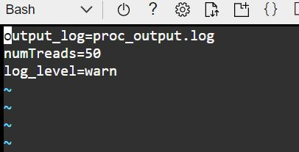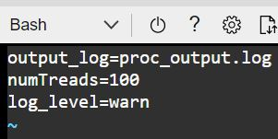

1. Push the changed file into the data lake container at its appropriate location.

